

Semester One Examination, 2024

Question/Answer booklet

MATHEMATICS METHODS
UNIT 3

Section Two:

Calculator-assumed

Your Name:
Your Teacher’s Name:

Time allowed for this section
Reading time before commencing work: ten minutes
Working time: one hundred minutes

Materials required/recommended for this section
To be provided by the supervisor
This Question/Answer booklet
Formula sheet (retained from Section One)

To be provided by the candidate
Standard items: pens (blue/black preferred), pencils (including coloured), sharpener, correction fluid/tape, eraser, ruler, highlighters

Special items: drawing instruments, templates, notes on two unfolded sheets of A4 paper, and up to three calculators approved for use in this examination

Important note to candidates
No other items may be taken into the examination room. It is your responsibility to ensure that you do not have any unauthorised material. If you have any unauthorised material with you, hand it to the supervisor before reading any further.

Question | Marks | Max | Question | Marks | Max
6 |  | 7 | 12 |  | 12
7 |  | 7 | 13 |  | 14
8 |  | 8 | 14 |  | 8
9 |  | 8
10 |  | 15
11 |  | 11

Structure of this paper

Section | Number of questions available | Number of questions to be answered | Working time (minutes) | Marks available | Percentage of examination
Section One:  Calculator-free | 5 | 5 | 50 | 46 | 33.8
Section Two:  Calculator-assumed | 9 | 9 | 100 | 90 | 66.2
 |  |  |  | Total | 100

Instructions to candidates

- The rules for the conduct of the Western Australian Certificate of Education ATAR course examinations are detailed in the Year 12 Information Handbook 2019. Sitting this examination implies that you agree to abide by these rules.

- Write your answers in this Question/Answer booklet.

- You must be careful to confine your answers to the specific questions asked and to follow any instructions that are specific to a particular question.

- Additional pages for the use of planning your answer to a question or continuing your answer to a question have been provided at the end of this Question/Answer booklet. If you use the space to continue an answer, indicate in the original answer space where the answer is continued, i.e. give the page number.

- Show all your working clearly. Your working should be in sufficient detail to allow your answers to be checked readily and for marks to be awarded for reasoning. Incorrect answers given without supporting reasoning cannot be allocated any marks. For any question or part question worth more than two marks, valid working or justification is required to receive full marks. If you repeat any question, ensure that you cancel the answer you do not wish to have marked.

- It is recommended that you do not use pencil, except in diagrams.

- The Formula sheet is not to be handed in with your Question/Answer booklet.

Section Two: Calculator-assumed (90 Marks)

This section has nine questions. Answer all questions. Write your answers in the spaces provided.

Spare pages are included at the end of this booklet. They can be used for planning your responses and/or as additional space if required to continue an answer.
● Planning: If you use the spare pages for planning, indicate this clearly at the top of the page.
● Continuing an answer: If you need to use the space to continue an answer, indicate in the original answer space where the answer is continued, i.e. give the page number. Fill in the number of the question that you are continuing to answer at the top of the page.

Working time: 100 minutes.

This page has been left blank intentionally. Go to the next page.

Question 6 (7 marks)
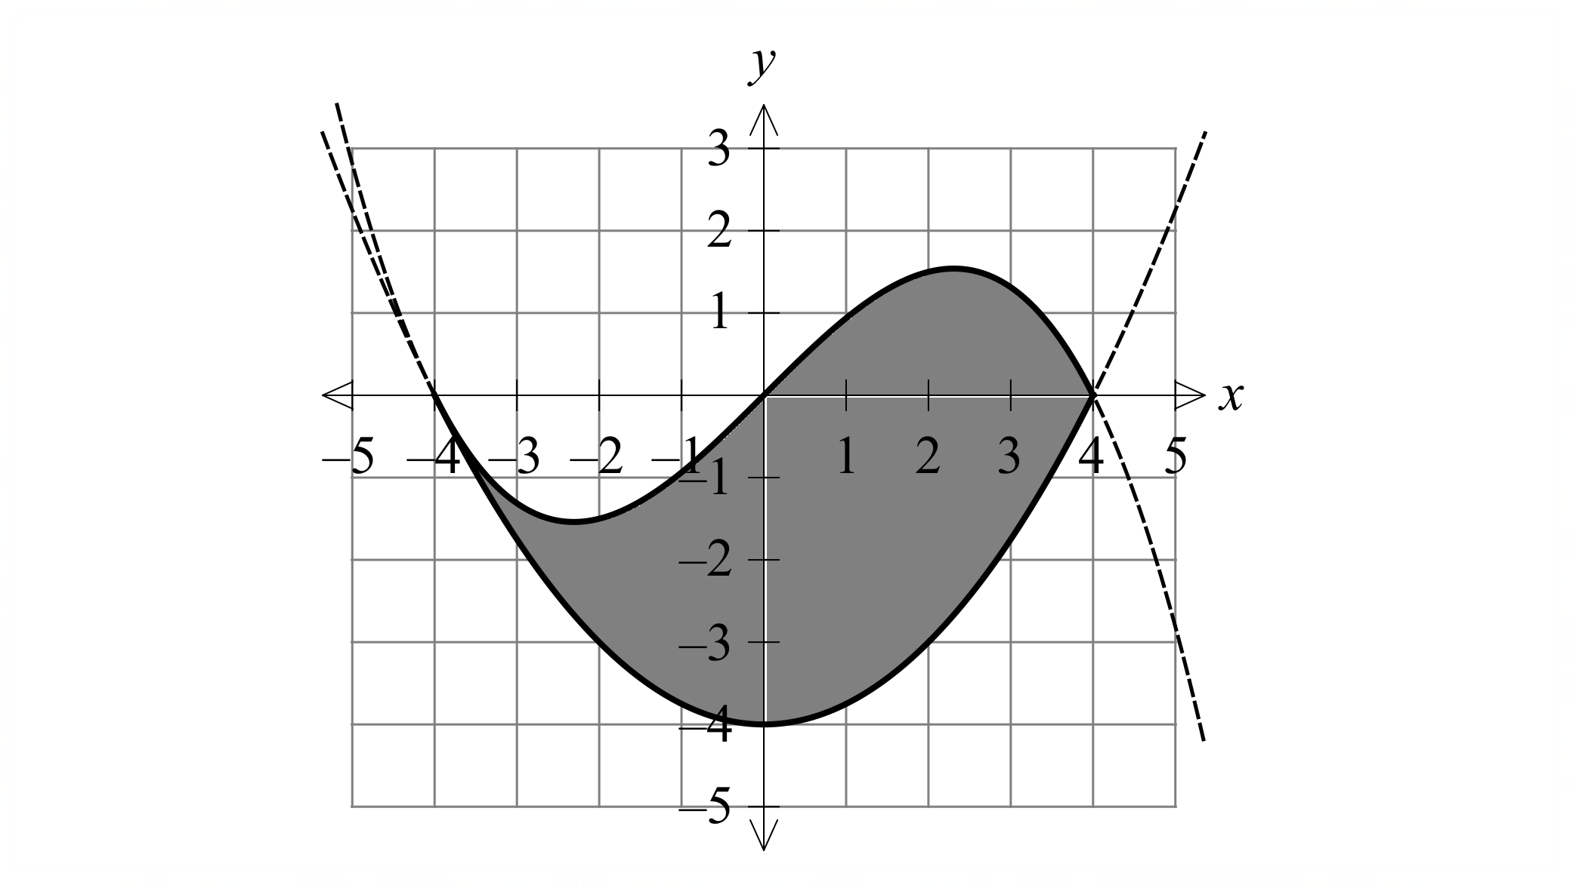
The diagram on the right shows a company logo shaded in grey.

The logo is bounded by two polynomials:

$$f\left(x\right)=\frac{1}{4}x^{2}-4$$
$$g\left(x\right)=k(16x-x^{3})$$

(a) Given that $f^{'}\left(-4\right)=g'(-4)$, determine the constant $k$. (2 marks)

(b) Justify that $g(x)$ has only one point of inflection at $(0, 0)$. (2 marks)

A three-dimensional version of the logo is to be produced in acrylic for placement on the outside of a building. Each unit on the axes represents $1$ m.

(c) If the logo needs to be $30$ cm thick, determine the volume of acrylic needed to produce the logo. (3 marks)

Question 7 (7 marks)
A tank initially contains $46$ litres of oil and $t$ hours later the rate of change of volume $V$ of oil in the tank is given by
$$\frac{dV}{dt}=-3e^{-0.06t}.$$

(a) At what rate is the volume of oil changing after $4.5$ hours? (1 mark)

(b) Determine an expression for $V$ as a function of time $t$. (2 marks)

(c) What volume of oil is in the tank after $6$ hours? (1 mark)

(d) The mathematical model for the rate of change is only valid until there is no oil left in the tank. At what time does this occur? (1 mark)

(e) Determine the rate at which oil is draining from the tank at the instant that it holds $6$ litres.
(2 marks)

Question 8 (8 marks)
A farmer plants saplings to replace trees felled for timber. The saplings grow independently of each other, and the farmer expects that $9\%$ of those planted will be lost to disease, insects, and other causes.

(a) The farmer plants $20$ saplings in a small field. For this plantation, determine

(i) the probability that $4$ saplings will be lost. (2 marks)

(ii) the probability that more than one sapling will be lost. (1 mark)

(iii) the most likely number of saplings that will be lost. (1 mark)

(b) In a much larger field, $45$ rows of $36$ saplings are planted.

(i) Show that the probability that in one randomly chosen row no more than $3$ saplings will be lost is $0.5912$. (2 marks)

(ii) Determine the probability that less than half of the rows will lose no more than
$3$ saplings. (2 marks)

Question 9 (8 marks)
The temperature $T$ $℃$ of an oven, $t$ minutes after being turned on, changes according to the function

$$\frac{dT}{dt}=at-\sin\left(\frac{t}{3}\right)+\frac{3}{4}\cos\left(\frac{t}{4}\right), 0≤t≤40,$$

where $a$ is a constant.

- When $a=0.3$, is the rate of change of temperature of the oven greater when
$t=1$ or $t=3$? Justify your answer. (2 marks)

(ii) When $a=0.3$ and the initial temperature of the oven is $17℃$, determine its temperature $30$ minutes after being turned on. (3 marks)

(iii) An oven had an initial temperature of $22℃$. Determine the value of the constant $a$ for this oven given that $15$ minutes after being turned on its temperature was $80℃$. (3 marks)

Question 10 (15 marks)
The velocity $v$ ms⁻¹ of a particle travelling along a straight line is shown on the graph below.

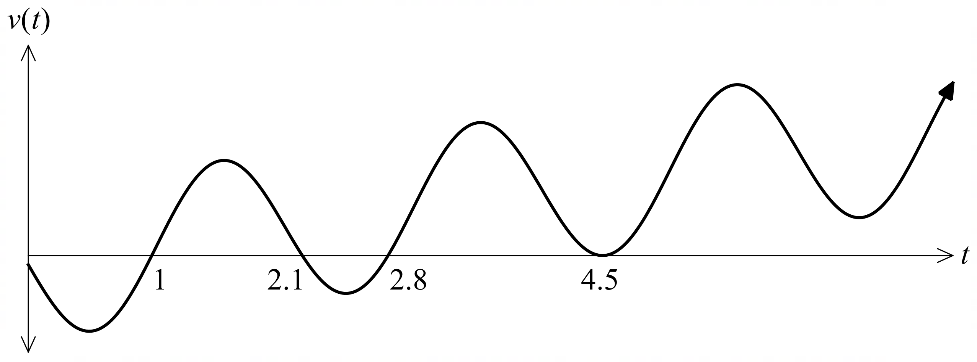

All the roots of $v(t)$ are shown on the graph above.

(a) How many times does the particle change direction? Justify your answer by referring to the above graph. (2 marks)

(b) What is the displacement of the particle as $t→∞$? Justify your answer by referring to the above graph. (2 marks)

The same velocity graph is shown below along with the $t$-coordinates of the turning points, and the area of the four regions ($A_{1}$, $A_{2}$, $A_{3}$ and $A_{4}$) that are enclosed between the graph and the $t$-axis.

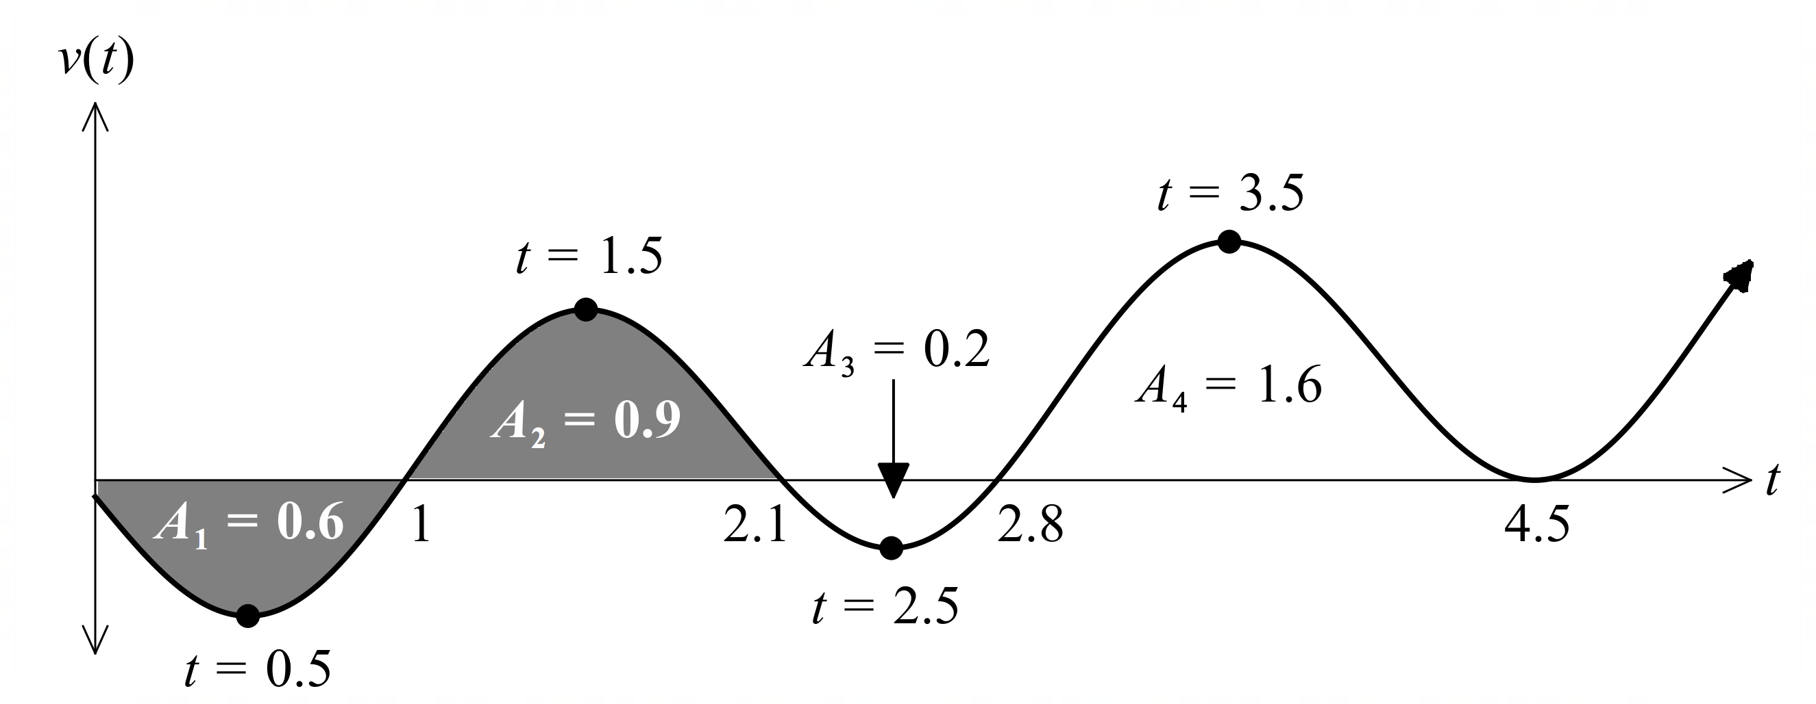

(c) Determine when the particle first has positive acceleration. (2 marks)

(d) (i) Write down an integral expression for the distance travelled in the first 4.5 seconds.
(2 marks)

(ii) Hence, determine the distance travelled in the first 4.5 seconds. (2 marks)

(e) Describe what the signed area of the shaded region in the figure represents. (2 marks)

The particle starts at the origin.

(f) Determine how many times that the particle will pass through the origin for $t>0$, justifying your answer. (3 marks)

Question 11 (11 marks)
Consider 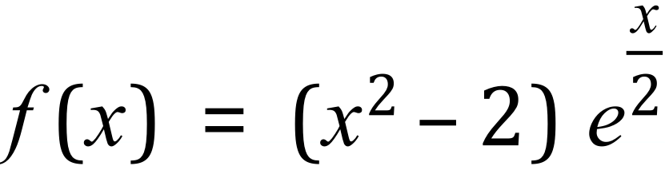
- Use calculus to determine all the stationary points of $f(x)$ and determine their nature. (5 marks)

- Determine the coordinates of any points of inflection. (2 marks)

- Hence sketch the graph of $f(x)$, clearly indicating the location of all stationary points and points of inflection. (4 marks)

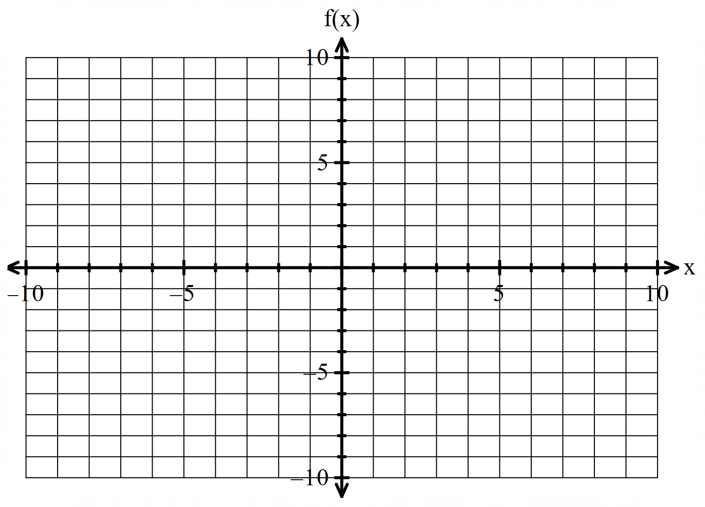

Question 12 (12 marks)
A group of Year 12 students plan to run a “Triple Roll” game stall for their school’s Community Day event.
The game consists of three 8-sided dice, numbered 1 to 8, each placed in a cup. The cup is shaken, the dice rolled, and the number of sevens are recorded.
Let X be a random variable denoting the number of sevens rolled in a Triple Roll game.
- State the distribution of X. (2 marks)

An incomplete probability distribution for X is shown in the table below.
$$x$$ | $$0$$ | $$1$$ | $$2$$ | $$3$$
$$P(X=x)$$ |  |  |  | $$\frac{1}{512}=0.002$$

- Complete the table above, providing the missing probabilities. (2 marks)

Each player pays $2 to play Triple Roll game. If a player rolls one 7 they win $2, if they roll two 7s, they win $4 and if they roll three 7s they win $7.
- Determine the school’s expected profit/loss for each game of Triple Roll. (3 marks)

- Determine the probability that a player will make a profit in a game of Triple Roll. (2 marks)

Year 12 students want to increase the attraction of the game by providing the opportunity for larger winnings. They modify the rules of the game so that players only win money when two or more 7s are rolled and the winnings for rolling three 7s is five times as much as the winning for rolling of two 7s. Each game still costs $2 to play. Year 12 students estimated that they should be able to run 300 games and wants to make profit of $200 for the school.

- Determine the winnings Year 12 students should set for rolling three 7s with the modifications above. (3 marks)

Question 13 (14 marks)
Calculus amusement park is planning to construct a zipline adventure above a scenic hill within its premises. The hill where the zipline will be installed is modelled by
$$h\left(x\right)=15x\left(π-\frac{x}{10}\right)+15\sin\left(x-\frac{π}{10}\right)$$
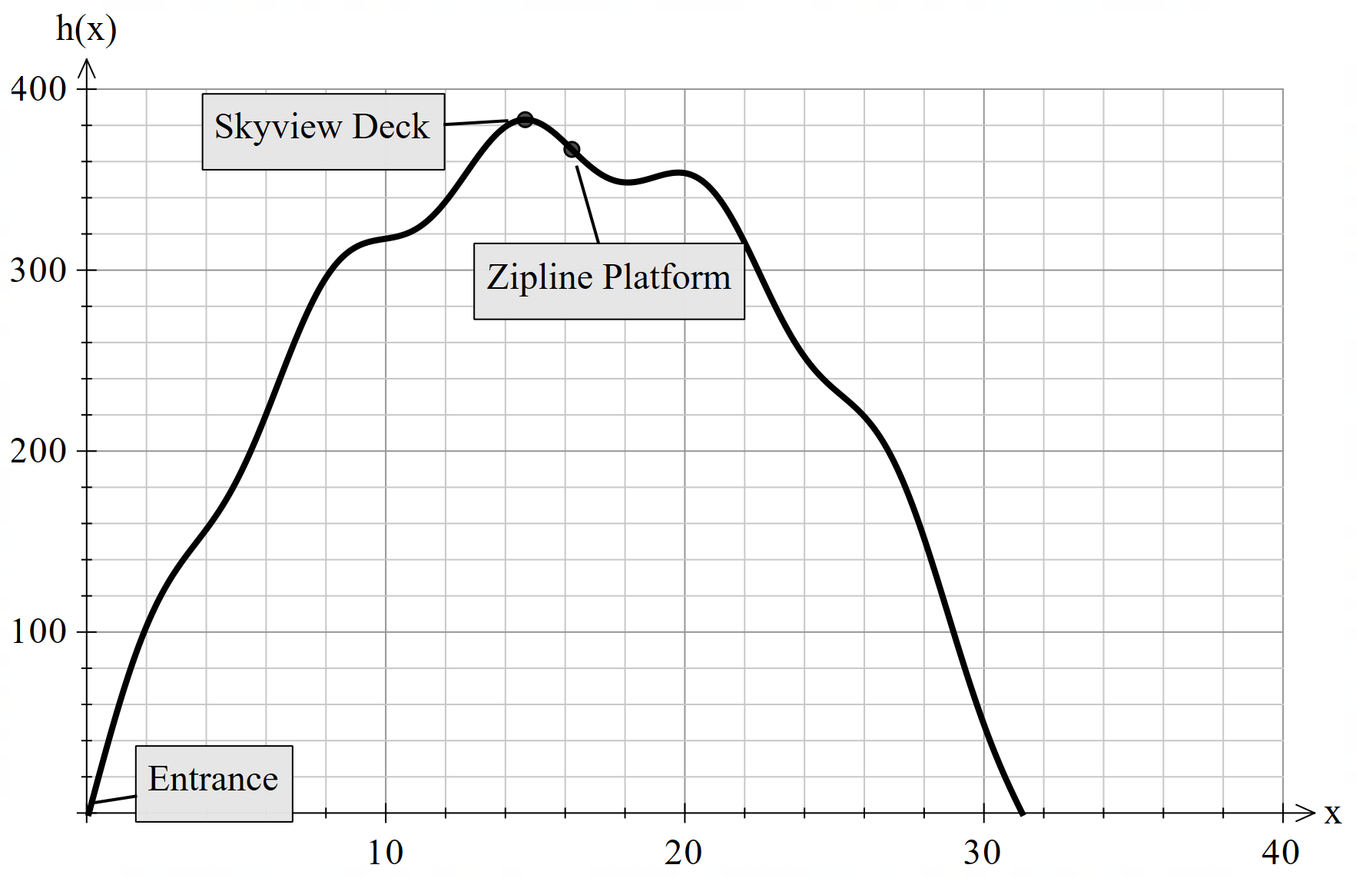where $h\left(x\right)$ is the height (in metres) of the hill and $x$ is the horizontal distance in metres.

- Determine $h^{'}(x)$. (2 marks)

- Visitors will need to take a cable car first to reach the Sky view Deck, which is the highest point of the hill. Determine, to the nearest centimetre, the value of $x$at which the height of the hill is maximum and state this maximum height. (4 marks)

- Visitors will take the cable car from the entrance to reach the sky view deck. This entrance is located at the first steepest point of the hill. How high off the ground, to the nearest centimetre is it positioned? Consider the horizontal distance, $0≤x≤5.$ (3 marks)

The distance,  , travelled along the zipline is given by
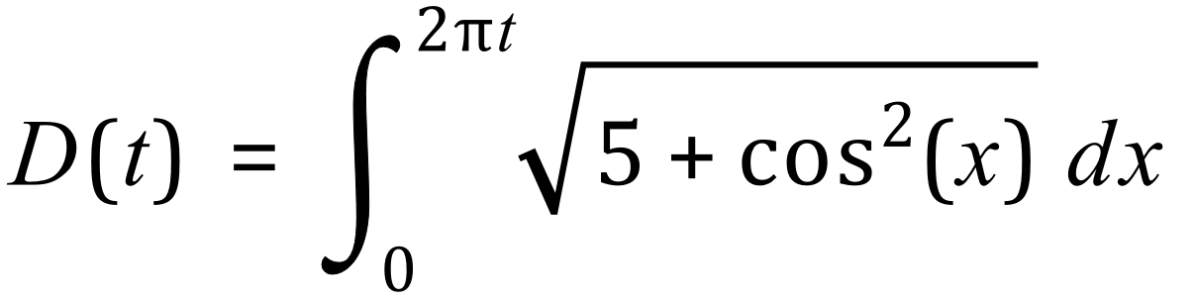
Where is measured in metres and 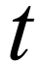 is measured in seconds.

- Determine the speed 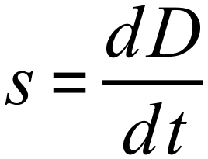 of the person on the zipline when 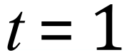 . (3 marks)

- Use the increments formula to estimate the distance travelled by the object between 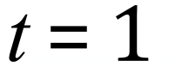 and 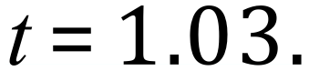 (2 marks)

Question 14 (8 marks)
The probability distribution of the discrete random variable $X$ is $P\left(X=x\right)=\left\{\begin{matrix}\begin{matrix}a \\ \overline{x}\end{matrix} & x=2, 3 \\ \begin{matrix}b \\ \overline{2x}\end{matrix} & x=4, 5, 6 \\ 0 & \text{otherwise}\end{matrix}\right.$
where $a$ and $b$ are constants and $E\left(X\right)=4.3$.

(a) Determine $P(X=3)$. (4 marks)

(b) Determine $P\left(X=5 | X<6\right)$. (2 marks)

(c) The discrete random variable $Y$ is only defined for two values of $y$, so that when $X$ is even
$y=0$ and when $X$ is odd $y=1$. Determine the variance of $Y$. (2 marks)

Additional working space
Question number: ________

Additional working space
Question number: ________

Additional working space
Question number: ________

